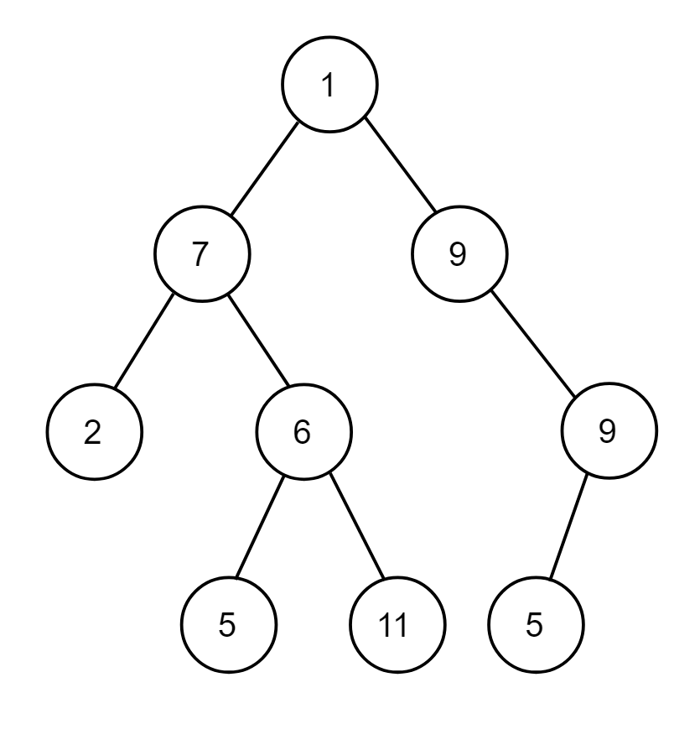

Write preorder, postorder and inorder traversal of this binary tree.
Tree – Non Linear Data Structure
Answer:
Preorder = 1,7,2,6,5,11,9,9,5
Inorder = 2,7,5,6,11,1,9,5,9
Postorder = 2,5,11,6,7,5,9,9,1

Data Structure :
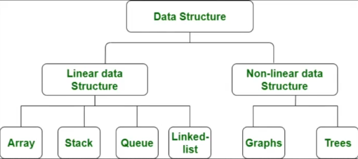

17_4 What is Binary Tree
2(two) child for 1(one) parent
[ Child not more than 2 ]

Creating Binary Tree Animated :
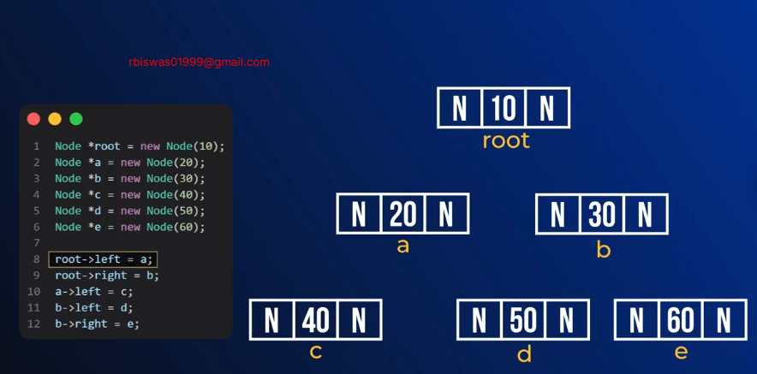

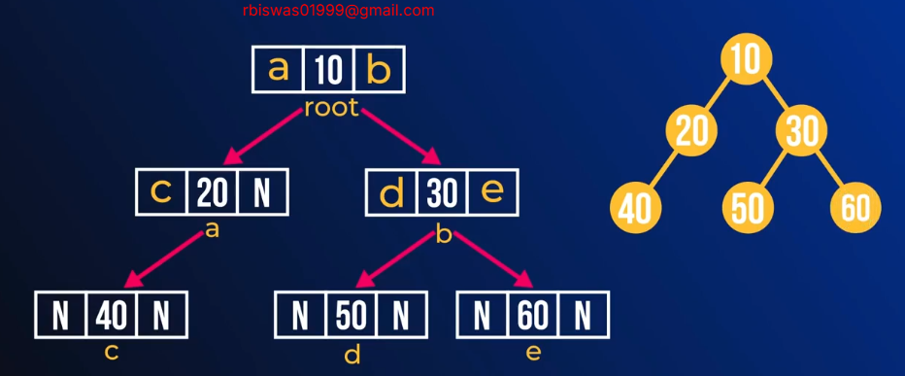

17_7 Printing Binary Tree

Order -> Depth – Wise -> Preorder
-> Inorder
-> Postorder
-> Level – Wise -> Level order

17_8 Preorder Traversal
Traversal :
PreOrder: Root Left Right
InOrder: Left Root Right
PostOrder: Left Right Root

10
/ \
20 30
/ / \
40 50 60

PreOrder: 10 – 20 – 40 – 30 - 50 – 60

17_9 Preorder Traversal Implementation
#include<bits/stdc++.h>
using namespace std;

class Node{
public:
int val;
Node* left;
Node* right;
Node(int val){
this->val=val;
this->left=NULL;
this->right=NULL;
}
};

void preOrder(Node* root){
if (root == NULL)
{
return ;
}

cout<<root->val<<" "; //root
preOrder(root->left); //left
preOrder(root->right); //right
}

int main(){
Node* root = new Node(10);
Node* a = new Node(20);
Node* b = new Node(30);
Node* c = new Node(40);
Node* d = new Node(50);
Node* e = new Node(60);

root->left=a;
root->right=b;
a->left=c;
b->left=d;
b->right=e;

preOrder(root);

return 0;
}

17_11 Inorder Traversal
#include<bits/stdc++.h>
using namespace std;

class Node{
public:
int val;
Node* left;
Node* right;
Node(int val){
this->val=val;
this->left=NULL;
this->right=NULL;
}
};

void inOrder(Node* root){
if (root == NULL)
{
return;
}
inOrder(root->left);
cout<<root->val<<" ";
inOrder(root->right);
}

int main(){
Node* root = new Node(10);
Node* a = new Node(20);
Node* b = new Node(30);
Node* c = new Node(40);
Node* d = new Node(50);
Node* e = new Node(60);

root->left=a;
root->right=b;
a->left=c;
b->left=d;
b->right=e;

inOrder(root);
return 0;
}

Postorder Traversal
#include<bits/stdc++.h>
using namespace std;

class Node{
public:
int val;
Node* left;
Node* right;
Node(int val){
this->val=val;
this->left=NULL;
this->right=NULL;
}
};

void postOrder(Node* root){
if (root == NULL)
{
return;
}
postOrder(root->left);
postOrder(root->right);
cout<<root->val<<" ";
}

int main(){
Node* root = new Node(10);
Node* a = new Node(20);
Node* b = new Node(30);
Node* c = new Node(40);
Node* d = new Node(50);
Node* e = new Node(60);

root->left=a;
root->right=b;
a->left=c;
b->left=d;
b->right=e;

postOrder(root);
return 0;
}

